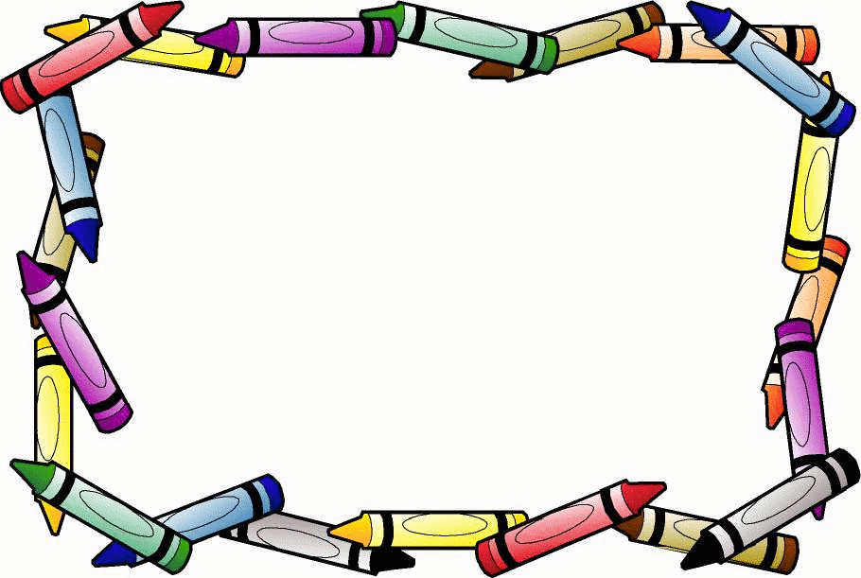

________ I am dressed.

________ I ate breakfast.

________ I brushed my teeth.

________ I put on my shoes.

________ I have my homework.

________ I have my lunch.

________ I have my backpack.

I am ready!

Are you ready?